H.T No
Regulations:
A20

Sreenidhi Institute of Science and Technology
(An Autonomous Institution)
Code No:8B205 Date:09 -August-2024 (FN)

B.Tech I-Year II- Semester External Examination, August-2024 (Supplementary)
MECHANICS OF SOLIDS (MECHANICAL)

Time: 3 Hours Max.Marks:70

Note: a) No additional answer sheets will be provided.
b) All sub-parts of a question must be answered at one place only, otherwise it will not be valued.
c) Missing data can be assumed suitably.

Bloom's Cognitive Levels of Learning (BCLL)

Remember | L1 | Apply | L3 | Evaluate | L5
Understand | L2 | Analyze | L4 | Create | L6

Part - A Max.Marks:20
Answer all QUESTIONS

 |  | BCLL | CO(s) | Marks
1 | Define strain energy. | L1 | CO1 | [2M]
2 | What is shear stress of solid circular shaft of diameter(D) in mm | L2 | CO2 | [2M]
3 | What is point of Inflection and Point of contra flexure | L2 | CO3 | [2M]
4 | Write down bending equation with units | L1 | CO4 | [2M]
5 | Write-down Section modulus formula of Hollow Rectangle and Hollow Circle | L2 | CO5 | [2M]
6 | Explain longitudinal and circumferential stress of cylinder. | L2 | CO6 | [2M]
7 | Define poison’s ratio | L1 | CO1 | [2M]
8 | What is the section modulus formula for rectangular section? | L1 | CO4 | [2M]
9 | Write-down Lame’s equations. | L2 | CO6 | [2M]
10 | What is shear stress of hollow circular shaft of major diameter(D) and minor diameter (d) in mm | L2 | CO2 | [2M]
Part – B Max.Marks:50
ANSWER ANY FIVE QUESTIONS. EACH QUESTION CARRIES 10 MARKS.

 |  |  | BCLL | CO(s) | Marks
11. |  | A load of 2 MN is applied on a short concrete column 500 mm × 500 mm. The column is reinforced with four steel bars of 10 mm diameter, one in each corner. Find the stresses in the concrete and steel bars. Take E for steel as 2.1 × 105 N/mm² and for concrete as 1.4 × 10^4 N/mm². | L3 | CO1 | [10M]
12. |  | A rectangular block of material is subjected to a tensile stress of 110 N/mm² on one plane and a tensile stress of 47 N/mm² on the plane at right angles to the former. Each of the above stresses is accompanied by a shear stress of 63 N/mm² and that associated with the former tensile stress tends to rotate the block anticlockwise. Find : (i) the direction and magnitude of each of the principal stress and (ii) magnitude of the greatest shear stress | L3 | CO2 | [10M]
13. |  | Draw shear force and bending moment diagrams for a cantilever with left end x=0 and right end x=L  - Point load at right end is W in Newton’s  - Uniformly distributed load (W in N/m) throughout length  - Uniformly varying load at x=0, W=0 and at x=L is W(N/m). | L3 | CO3 | [10M]
14. |  | A cantilever of length 2 meters fails when a load of 2 kN is applied at the free end.  - If the section of the beam is 40 mm × 60 mm,  - If the section is circular with diameter is 45mm  Find the bending stress at the failure with above two cross-sections. | L3 | CO4 | [10M]
15. |  | A cantilever beam is loaded with uniformly distributed load of 20 kN/m. Determine maximum deflection (use any method) and the location of its occurrence.  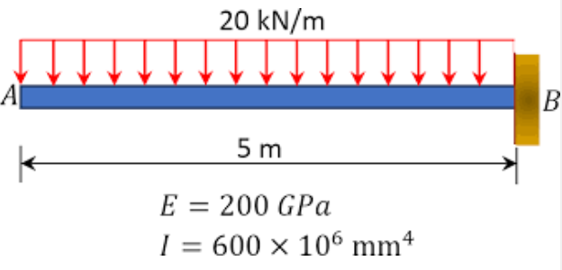 | L4 | CO5 | [10M]
16. |  | Calculate: (i) the change in diameter, (ii) change in length and (iii) change in volume of a thin cylindrical shell 100 cm diameter, 1 cm thick and 5 m long when subjected to internal pressure of 3 N/mm². Consider the value of E = 2 × 10⁵ N/mm² and Poisson’s ratio = 0.3. | L3 | CO6 | [10M]
17. | a) | Find the Young’s Modulus of a brass rod of diameter 25 mm and of length 250 mm which is subjected to a tensile load of 50 kN when the extension of the rod is equal to 0.3 mm. | L2 | CO1 | [4M]
 | b) | A rectangular bar of cross-sectional area of 11000 mm² is subjected to a tensile load P as shown in Fig. The permissible normal and shear stresses on the oblique plane BC are given as 7 N/mm² and 3.5 N/mm² respectively. Determine the safe value of P.  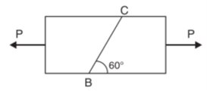 | L3 | CO2 | [3M]
 | c) | Draw S.F and B.M of double overhang beam with uniformly distributed load (W N/m). | L3 | CO3 | [3M]
18. | a) | A beam of rectangular cross-section is subjected to a vertical shear force V, find the shear force carried by the upper one-third of the cross-section. | L2 | CO4 | [4M]
 | b) | A simply supported beam is subjected to a uniformly distributed load of intensity W per unit length. On half of the span from one end. The length of the span and the flexural stiffness are denoted as/and EI, respectively. Calculate the deflection at mid-span of the beam. | L3 | CO5 | [3M]
 | c) | A thin gas cylinder with an internal radius of 100 mm is subject to an internal pressure of 10 MPa. The maximum permissible working stress is restricted to 100 MPa. Find the minimum cylinder wall thickness (in mm) for safe design. | L3 | CO6 | [3M]
-- 00 -- 00 –

